Cell DCR measure procedure

Version: X2

Issued by: Kylin Date: Aug. 15, 2013

Checked by: CYW Date: Aug. 15, 2013

Approved by: Date:

Contents
Revision History 3
1 Purpose 4
2 Scope of application 4
3 Measure step 4
4 DCR calculate formula 5
5 Example of 5514 project 5

Revision History

Rev. | Date | Update content | By
X1 | Aug.12,2013 | First Revision. | Kylin
X2 | Aug.15.2013 | 1, Use the standard format to report  2, Add three steps into item4(measure step) | Kylin

1 Purpose
Measure the DC Resistance (DCR) of Li-ion or lithium iron phosphate battery accurately.

2 Scope of application
This cell DCR measure method can be used on Li-ion and Lithium iron phosphate battery.

3 Measure step
- Discharge cell to 2.75V at 0.5C current, rest 20 minutes;
- Charge cell in fully at 0.5C current, rest 20 minutes (Li-ion battery fully voltage is 4.2V, lithium iron phosphate battery fully voltage is 3.65V);
- Discharge 0.5C for 10 minutes, rest 20 minutes
- Use E-load to discharge: CC: 2C@10s→CC:0.5C@10s→CC:2C@10s;
- Use logger to record the Cell voltage and current of ‘d’ step(Set scan time 0.1s);
- Use the logger data to create the scatter diagram as figure1 show.
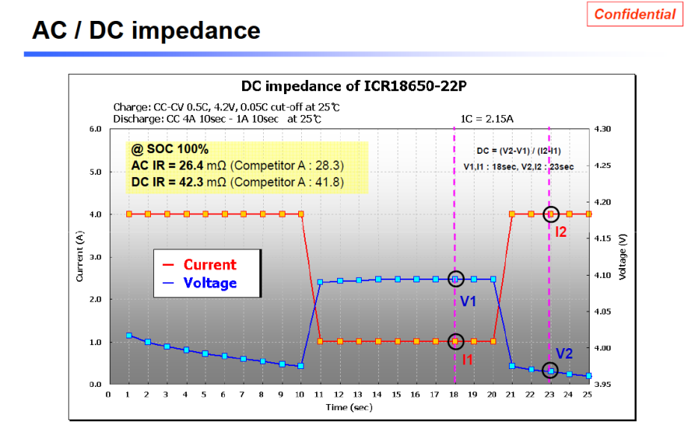
Figure1

4 DCR calculate formula

Cell DCR=(V2-V1)/(I1-I2)

V1 is 18th second voltage;

V2 is 23rd second voltage;
I1 is 18th second current;
I2 is 23rd second current.

5 Example of 5514 project
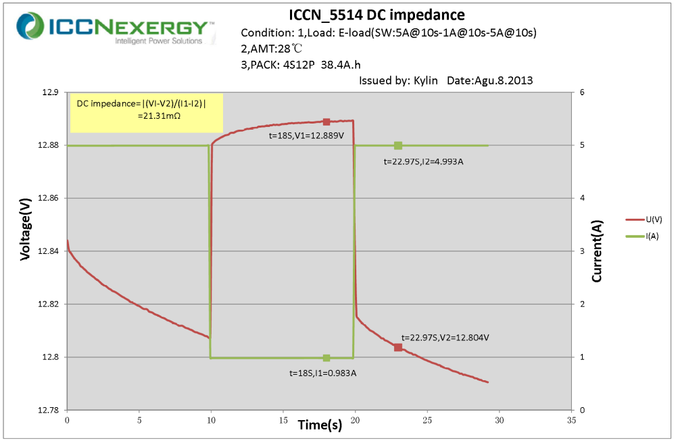
Figure2

